Name : MUHAMMAD MUBASHAR ALI

Student ID : BSIET02213012

Subject : Object Oriented Programming

Lab : 05

Example # 01

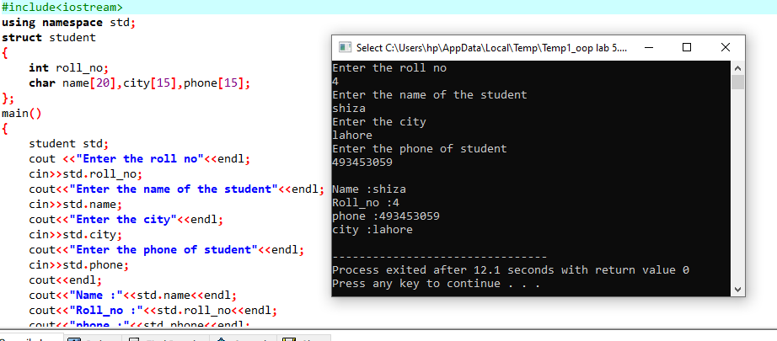

Example # 02

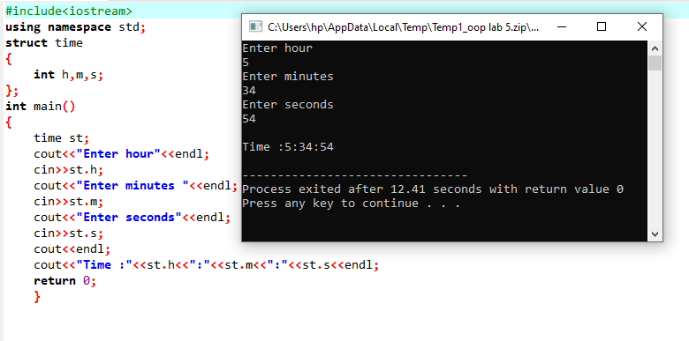

Example # 03

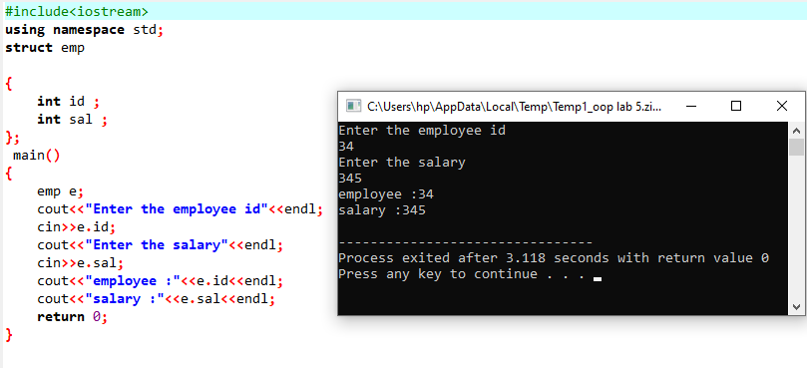

Example # 04

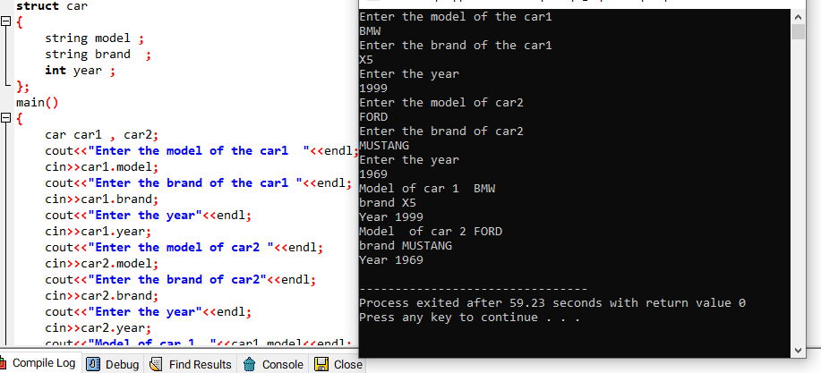

Lab Exercise Program

Example # 05

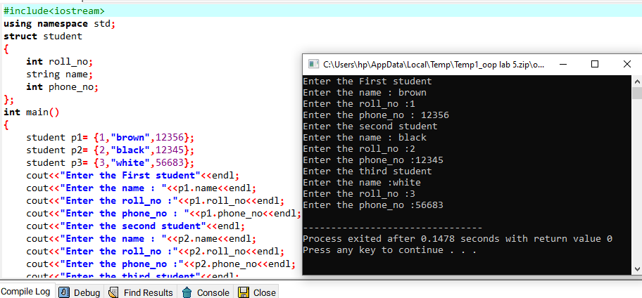

Example # 06

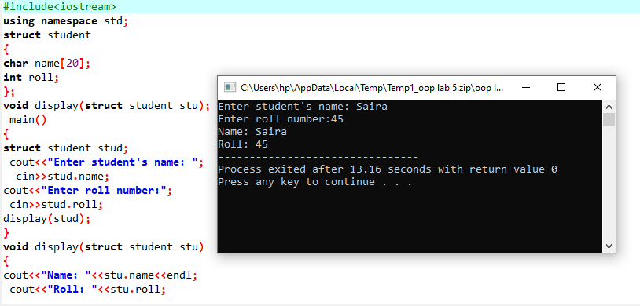

Example # 07

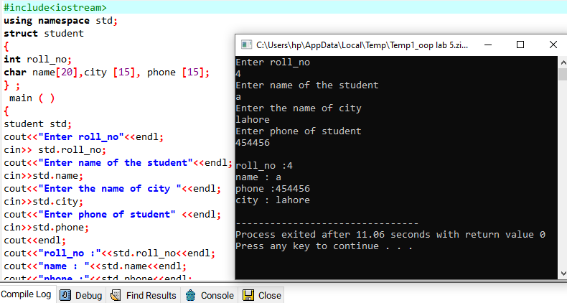

Review Questions

Question # 01

A phone number, such as (212) 767-8900, can be thought of as having three parts: the area code (212), the exchange (767), and the number (8900). Write a program that uses a structure to store these three parts of a phone number separately. Call the structure phone. Create two structure variables of type phone. Initialize one, and have the user input a number for the other one. Then display both numbers. The interchange might look like this:

Enter your area code, exchange, and number: 415 555 1212

My number is (212) 767-8900

Your number is (415) 555-1212

Answer

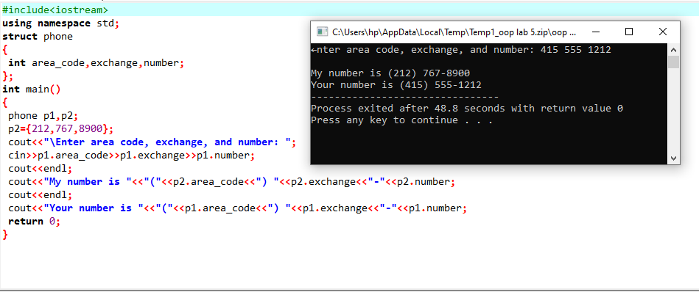

Question # 02

Create a structure called Volume that uses three variables of type Distance to model the volume of a room. Initialize a variable of type Volume to specific dimensions, then calculate the volume it represents, and print out the result. To calculate the volume, convert each dimension from a Distance variable to a variable of type float representing feet and fractions of a foot, and then multiply the resulting three numbers.?

Answer

